TASK 2

- Devops user don’t have the permission to create the file in home since it don’t have a root user privilege .
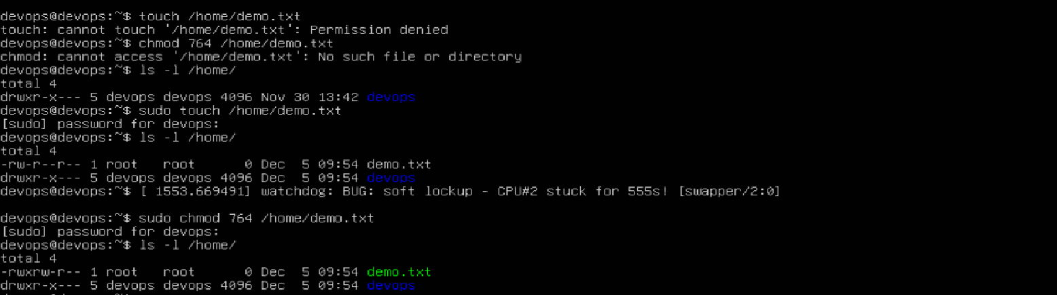

Switched to the root user and edit the file , here while listing file we can see the root is the user which can access file ie (it has read r write w execute x persmission).

